

**TITLE OF REPORT:** Human Detection Probe for Post-Earthquake Debris Using a PIR Motion Sensor

**BY**

Daniël Jacobus Robbertse (577320)

Luan Davel (577364)

Manissha Packary (577639)

Maryam Jhavary (577869)

**COURSE:** Internet of Things 281

**DEPARTMENT:** Department of Computing

**UNIVERSITY:** Belgium Campus ITversity

**Submission Date: 05 October 2023**

# Abstract

The project focuses on creating a human detection probe system that is intended to assist in disaster response scenarios, with an emphasis on finding people who are trapped under rubble after an earthquake. The device uses a passive infrared (PIR) motion sensor to recognize the heat signatures of people and send out visual and audio alerts as a result. To aid rescue crews in finding and freeing trapped people, these signals incorporate a flashing red LED, a piezo buzzer, and an LCD display. This ground-breaking device has the potential to greatly enhance post-disaster response initiatives and save lives in dire circumstances.

# Executive summary

Time is of the essence in discovering and rescuing trapped people in disaster response scenarios, such as building collapses following an earthquake. Communication issues frequently plague traditional systems, making it difficult to locate survivors rapidly. Our proposal offers a person detecting probe system using a PIR motion sensor to overcome this problem. A flashing red LED, a piezo buzzer, and an LCD display are just a few of the visual and audible alerts that are triggered when this device detects the heat signatures of people. By giving rescue crews access to up-to-the-minute information, these alerts improve the efficiency and precision of rescue operations. The non-contact nature of the device guarantees the security of both survivors and rescuers. This initiative has the potential to have a substantial influence on disaster response efforts by accelerating the identification and rescue of those in need.

Table of Contents

Abstract 2

Executive summary 3

List of figures 5

Introduction 6

Background 6

Current technologies used in aiding rescue teams 7

Issues with certain technology: 7

PIR Motion Sensors: 8

Our Projects Objective: 8

Methodology: 9

Components used 10

Circuit design 18

Results: 24

Conclusion 25

References 25

Appendix 26

# List of figures

[Figure 1: Tinkercad Design 18](https://belgiumcampusacza-my.sharepoint.com/personal/577869_student_belgiumcampus_ac_za/Documents/IOT281%20-%20Project_Technical_Report.docx#_Toc147442509)

[Figure 2: Circuit Schematic 19](https://belgiumcampusacza-my.sharepoint.com/personal/577869_student_belgiumcampus_ac_za/Documents/IOT281%20-%20Project_Technical_Report.docx#_Toc147442510)

Figure 3:Green wire connects to OUT terminal on PIR 20

Figure 4: Light blue wire connects to VCC terminal on PIR 20

Figure 5: PIR Sensor 21

Figure 6: LED, buzzer and its resistors 21

Figure 7: Blue wires connect to LCD 22

Figure 8: Light blue wires connect to VCC terminal on LCD 23

Figure 9: LCD 23

Figure 10: Pushbutton connected to Arduino board 24

# Introduction

The objective of this project is to develop a system designed to tackle a challenge in a natural disaster response: detecting if there are any humans trapped under debris after an earthquake.

Our system utilizes a PIR (Passive Infrared) motion sensor, to detect the heat signatures of individuals who may be trapped underneath rubble. When an individual has been detected, the system triggers multiple alerts for rescue teams. It activates a buzzer and flashes a red LED, while an LCD screen displays a prominent alert message indicating the detection of heat signatures.

This system holds the potential to significantly enhance disaster response efforts, enabling rescue teams to rapidly locate and retrieve individuals trapped in precarious situations.

This project is significant because it has the power to speed life-saving rescue operations in the aftermath of earthquakes.

## Background

In the aftermath of a building collapse, the search for survivors becomes a race against time, as the chances of survival are intrinsically linked to the passage of time (Statheropoulos, et al., 2015).Trapped individuals often face significant communication challenges, particularly when they find themselves in areas with unreliable or non-existent cellular connectivity. Furthermore, some may be too weak or incapacitated to call for help or respond to rescuers, leading to communication breakdowns that hinder effective coordination and timely assistance (Dhanesha, 2023). Consequently, rescue teams must act swiftly to save victims who may be seriously injured and in urgent need of medical attention.

Current technologies used in aiding rescue teams:

A vital tool for finding aware people hidden behind wreckage is the *seismic detector*. They locate survivors by using highly sensitive seismic sensors that rely on seismic technology. Through a control box, these detectors enhance vibrations that are found inside the collapsed building (Anon., 2023). This technology has very few drawbacks, which makes it a crucial component of rescue operations.

## Issues with certain technology:

The foundation of the *ultra-wide band (UWB) rescue radar* is the transmission of incredibly short impulses. It emits electromagnetic waves with an ultra-sensitive UWB sensor that can penetrate a variety of building materials (Anon., 2023). However, because it can only scan up to 50 cm of solid materials, it may not be as useful in deeper rescue situations.

The *FINDER (Finding Individuals for Disaster Emergency Response)* devices use microwave radar sensors to detect a person's heartbeat and breathing remotely when they are buried by an avalanche or other debris (Pultarova, 2023). Although their primary target is cognizant people, in this case it is possible that they could miss survivors who are unconscious.

Although *search cameras* have convenient capabilities like picture recording and remote viewing, their constraints in terms of size, cost, power, and line-of-sight prevent them from being widely used.

However, they are ineffectual in inaccessible places or dim lighting conditions. *Fiber optics and borescopes* give generic information about victims' placements and conditions.

*Thermal and infrared cameras* are useful for scanning vast, dark regions and penetrating smoke and dust. However, in the presence of other heat sources, misinterpretation might happen.

For covering wide regions and using specialized methods like triangulation to locate victims, electronic listening devices are helpful. Their drawbacks include a constrained seismic and acoustic range, as well as an inability to identify individuals who are unconscious (Statheropoulos, et al., 2015).

## PIR Motion Sensors:

Passive infrared (PIR) sensors made of pyroelectric materials are able to detect any moving body that emits heat. Due to its built-in heat sensing and measuring capabilities, this "on the fly" presence detection has found use in a number of applications. For instance, when hands are put below a faucet, it opens. More range and object localization capabilities can be added to PIR sensors (Narayana, et al., 2015).

Everyone and everything, including people, animals, and even inanimate objects, emits some infrared light. The temperature of a person's body or an object, as well as the material it is made of, affect how much infrared radiation is present. Although infrared cannot be seen by humans, we have created electronic detecting tools that can. PIR sensors are commonly employed in heat sensing applications like security and motion detection (Wang, 2022).

## Our Projects Objective:

In order to meet our project's primary objective, which is the rapid detection and rescue of individuals trapped beneath debris, we will implement a PIR motion sensor. The utilization of PIR motion sensors aims to detect the heat signatures of survivors even in challenging disaster scenarios.

As mentioned earlier PIR motion sensors are renowned for their sensitivity to infrared radiation emitted by warm objects, making them ideal for identifying human body heat. In our system, these sensors will play a pivotal role in the early detection of survivors. As the sensor-equipped device is maneuvered over the debris, the PIR sensors will continually scan the surroundings for any sources of emitted infrared light, which typically correspond to the body heat of trapped individuals. When an infrared signature is detected, the system will activate and alert rescue teams to the presence of a potential survivor.

This innovative approach offers several advantages. Firstly, it leverages the non-contact nature of PIR sensors, ensuring the safety of both survivors and rescuers during the detection process. Moreover, the speed and accuracy of this technology reduce the time required to locate victims, which is crucial in situations where every moment counts.

# Methodology:

The "Methodology" portion of this report explores the methodical approach and techniques used to achieve the project's goals, which include the design and development of a human detecting probe for use in post-earthquake circumstances employing a PIR motion sensor. This section gives a thorough description of the methods, elements, and techniques used in creating and putting into use our technology.

The relevance of this project in the context of disaster response was established, and the key technologies involved, notably the PIR motion sensor, were presented, in the preceding "Background" section. We will now go into further depth about how these ideas were turned into a working prototype.

The methodology employed encompasses the selection of components, their subsequent design, thorough circuit development, and the creation of Arduino code to govern the behaviour of the device.

To provide a thorough comprehension of the procedures that underlie the successful development of our system, we shall outline each aspect of the approach in the sections that follow. Readers will acquire understanding of the complexities of our project through this in-depth explanation, enabling them to duplicate and build upon our work in future ventures.

Components used:

* Breadboard

The integral core of our electronic circuit is the half-sized breadboard, a versatile and indispensable tool in electronics prototyping. The breadboard serves as the platform for arranging and connecting electronic components in a temporary and modular fashion, facilitating experimentation and testing.

Layout: The breadboard features 30 rows and 10 columns, resulting in 300 tie-points. These tie-points are electrically connected within each row and column but isolated from each other. Additionally, it has 2 pairs of power rails.

Usage: Throughout the project, the breadboard acted as a central hub for connecting various electronic elements, including the PIR motion sensor, LEDs, LCD display, buzzer, and resistors. Its reusability and flexibility have been instrumental in rapid circuit iterations and testing.

* Parallax 555-28027 PIR Sensor

The Passive Infrared (PIR) motion sensor, a complex yet small electronic component intended to detect changes in heat signatures within its range of view, is the brain of our human detection probe. A crucial component of the functioning of our project is the detection of human presence, which is made possible by the PIR sensor.

Principle of Operation: The PIR sensor works by monitoring variations in infrared radiation generated by things in its immediate surroundings. It is very sensitive to the heat signatures released by living things, which makes it perfect for sensing the presence of people (Wang, 2022).

Sensor Specifications: Our chosen PIR sensor features the following specifications:

|  |  |
| --- | --- |
| Max Operating Temperature | 50 °C |
| Min Operating Temperature | 0 °C |
| Max Supply Voltage (DC) | 6 V |
| Min Supply Voltage (DC) | 3 V |
| Operating Supply Current | 23 mA |
| Sensing Distance | 6.096 m |
| Sensing Method | Infrared (IR) |
| Weight | 9.253284 g |
| Height | 25.4 mm |
| Length | 32.2 mm |
| Width | 24.3 mm |

Usage: Our system's PIR sensor is a key component; it is positioned as a probe to sweep through debris in post-earthquake conditions. The sensor alerts the system to activate the alarm mechanisms, such as the buzzer, LED, and LCD display, when a human heat signature is detected within its range.

Integration: We carefully positioned the PIR sensor to enhance its detecting abilities by integrating it into our circuit design. The Arduino microcontroller processes the sensor's data to make judgments about alert activation in real-time.

* Piezo Buzzer

Our human detecting probe uses the Piezo Buzzer as a fundamental audio output device. When a human presence is recognized by our system, it is crucial in generating audio warnings and notifications.

Operating Principle: The Piezo Buzzer works on the piezoelectric effect, which produces sound when mechanical force is applied to a piezoelectric crystal. It is renowned for being straightforward, effective, and capable of producing a variety of audible tones (Quisure, 2020).

Specifications:

|  |  |
| --- | --- |
| Operating Voltage AC | 3.5 - 5.5 V |
| Rated Voltage | 5 Vac |
| Current Consumption: | 25 mA |
| Resonant Frequency | 2300500 Hz |
| Height | 9.5mm |
| Connector Type | PCB Mount Leads |
| Sound | Continuous beeping |

Usage: An essential part of our alarm system is the piezo buzzer. The buzzer is actuated to produce a distinct auditory alarm, alerting both rescue crews and possible survivors of the presence of life when a human heat signature is found beneath debris. The audible indication aids in quickly identifying and removing those who require assistance.

Integration: In our circuit design, the Piezo Buzzer is integrated with the Arduino microcontroller. The microcontroller triggers the buzzer to emit the alert tone when human presence is detected by the PIR motion sensor.

* Red LED

In our human detection probe, the Red LED plays a crucial role as a visual signal. As a conspicuous visual warning method, it increases the visibility of alerts produced by our system.

Operating Principle: The electroluminescence concept underlies how LEDs operate. An electrical and optical phenomena known as electroluminescence occurs when an electric current is sent through a substance, causing it to generate light. Minority charge carriers and majority charge carriers recombine at the junction when a current is sent through the diode. Energy is emitted in the form of photons during recombination. The light intensity rises and reaches a maximum as the forward voltage rises (BYJU'S, no date).

Specifications:

|  |  |
| --- | --- |
| Forward Voltage DC | 1.8 - 2.2 V |
| Max Current | 20 mA |
| Rated Forward Current | 16 -18 mA |
| Luminous Intensity | 150 - 200 mcd |
| Colour | Red |
| Length | 5 mm |

Usage: In our alarm system, the Red LED is essential. The Red LED is triggered to generate a visible red light when a human heat signature is picked up by the PIR motion sensor. An essential feature is that the LED is set up to flash rapidly, producing a distinctive flashing pattern that grabs attention and clearly signals the existence of life beneath the debris.

Integration: The Red LED is seamlessly integrated into our circuit design. The Arduino microcontroller controls the LED's activation and flashing pattern, ensuring synchronization with other alert mechanisms.

* 16x2 LCD (Liquid Crystal Display)

The 16x2 LCD is a crucial visual output component integrated into our human detection probe. It provides a text-based interface for displaying critical information and system status.

Operating Principle: Liquid crystals form the foundation of the LCD. One pixel is produced by each liquid crystal. These are spinning the light and are sandwiched between two polarizers. Polarization doesn't cause the light to twist as it moves towards our eye when a certain voltage is directed at them since they are self-correcting. We can thus discern active pixels (Soldered, no date).

Specifications:

|  |  |
| --- | --- |
| Size: | 16 characters in 2 rows |
| Supply Current | 2 mA |
| Voltage | 5V |
| Display size | 64.5 x 16 mm |
| Size of module | 80 x 36 x 12 |
| Character colour | White |
| Background Colour | Blue |

Usage: The 16x2 LCD serves as a primary user interface element of our system. It displays real-time information regarding the status of the human detection probe, including alerts, system messages, and diagnostic data. When a human heat signature is detected by the PIR motion sensor, the LCD is employed to convey an alert message, such as "Heat signatures detected. Please press the button to reset."

Integration: The LCD is seamlessly integrated into our circuit design and controlled by the Arduino microcontroller. The microcontroller sends text messages to the LCD to display relevant information, ensuring that rescue teams and survivors receive immediate updates about the detected presence of life.

* Normally Open Pushbutton

The Normally Open Pushbutton, often referred to as a momentary pushbutton switch, is a fundamental user input component in our human detection probe. Its primary function is to provide users with a tactile means of resetting the system after a human heat signature has been detected by the PIR motion sensor.

Operating Principle: A particular kind of electrical switch is a normally open switch. Normally open switches stay "off" when they are not compressed. The electrical connections within are the source of this. When a switch is off, the contacts of a typically open switch are open. The switch is "off" as a result of the electrical connection being damaged. When contacts in a normally closed switch are closed, the switch is connected, indicating that when the contacts are not squeezed, the switch is turned "on” (Herga, no date).

Specifications:

|  |  |
| --- | --- |
| Contact Rating @ Voltage DC | 0.05A @ 24V |
| Actuator Type | Standard |
| Actuator Height off PCB, Vertical | 5.00mm |
| Luminous Intensity | 6.00mm x 6.00mm |
| Operating Temperature | -25°C ~ 70°C |
| Actuator Orientation | Top Actuated |

Usage: The normally open pushbutton is used as a user input device for system reset. The system activates an alarm with a flashing Red LED, a loud Piezo Buzzer and the LCD with an alert message when the PIR motion sensor detects a human heat signature. The system may be reset by pressing the pushbutton, which will silence the warning and get it ready for the subsequent detection event.

Integration: The pushbutton is seamlessly integrated into our circuit design, connected to the Arduino microcontroller. The microcontroller monitors the pushbutton's state and responds by resetting the system when it detects a button press.

* 220 Resistors

The 220-ohm resistors are fundamental passive electronic components employed in our human detection probe's circuit. They serve specific roles in current limiting for both LEDs (Light Emitting Diodes) and the Piezo Buzzer, ensuring proper operation of these components.

Operating Principle: Resistors, in general, are passive components that resist the flow of electrical current. The 220-ohm resistors, in particular, provide a fixed resistance of 220 ohms to control the current passing through specific components.

Specifications:

|  |  |
| --- | --- |
| Resistance | 220Ω |
| Power (Watts) 0.25W, 1/4W | 0.25W, 1/4W |
| Temperature Coefficient | 350ppm/Celsius |
| Tolerance | +/- 5%m |
| Case | Axial |
| Size | 2.40mm x 6.30mm |

Usage:

LED Current Limiting: One of the 220-ohm resistors is connected in series with an LED. This resistor plays a crucial role in current limiting, ensuring that the LED receives a safe and controlled current. This prevents overdriving, which could lead to premature LED failure and maintains the desired brightness level.

Buzzer Current Limiting: The other 220-ohm resistor is connected in series with the Piezo Buzzer. It serves a similar function, controlling the current flowing through the buzzer to ensure it operates within its specified parameters. This ensures that the buzzer emits the intended audible alert at the appropriate volume.

Integration: The 220-ohm resistors are seamlessly integrated into the circuit design, connected in series with the respective LEDs and the Piezo Buzzer. The resistor values are chosen to provide appropriate current limiting for these components, maintaining their safe and reliable operation.

## Circuit design

The electronic circuit design is a critical component of our human detection probe project. This section outlines the systematic process we followed to design and create the circuit, which serves as the backbone of our system.

1. Circuit Architecture:

We developed a comprehensive circuit architecture to illustrate the connections and relationships between the chosen components. The circuit architecture acts as a blueprint for our design and ensures that all components are correctly interconnected.

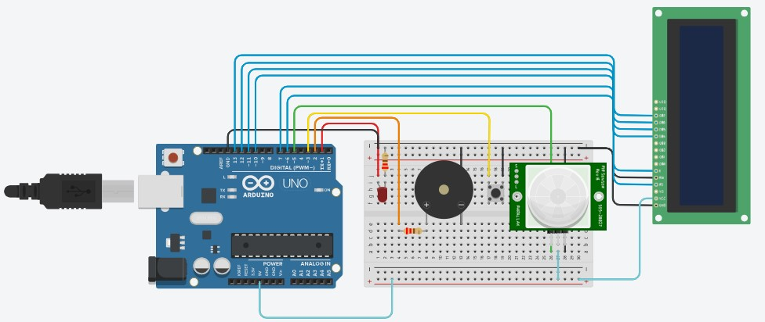Circuit Architecture Diagram

Figure 1: Tinkercad Design

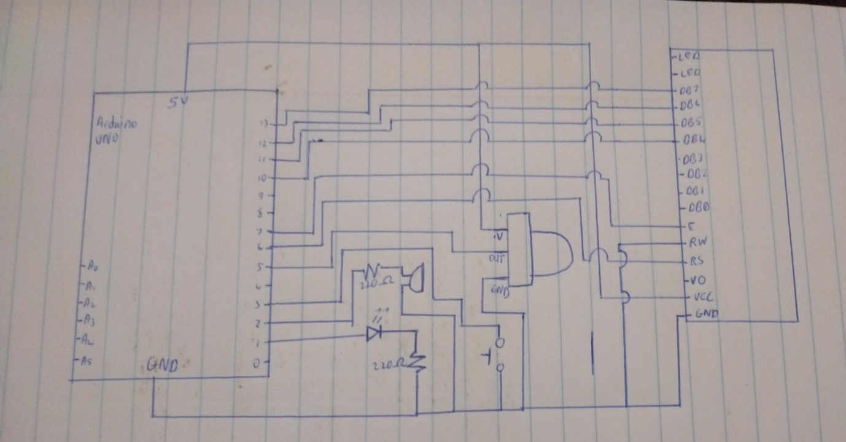

Figure 2: Circuit Schematic

2. PIR Sensor Integration:

The PIR motion sensor serves as the primary input device for our system, detecting human heat signatures. We integrated the PIR sensor into the circuit by connecting its VCC , GND, and OUT pins to the 5V, GND, 5TH Arduino pins respectfully.

PIR Sensor Connection

Figure 3:Green wire connects to OUT terminal on PIR

Figure 4: Light blue wire connects to VCC terminal on PIR

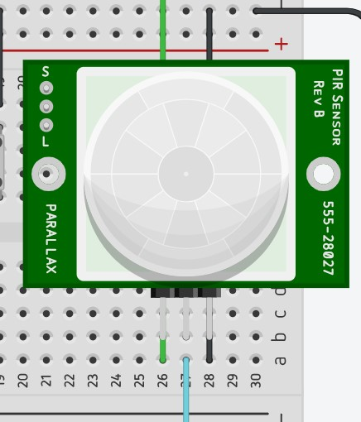

Figure 5: PIR Sensor

3. LED and Buzzer Integration:

To provide visual and audible alerts, we integrated the Red LED and Piezo Buzzer into the circuit. A 220-ohm resistor was placed in series with each component to ensure appropriate current limiting.

LED and Buzzer Connection

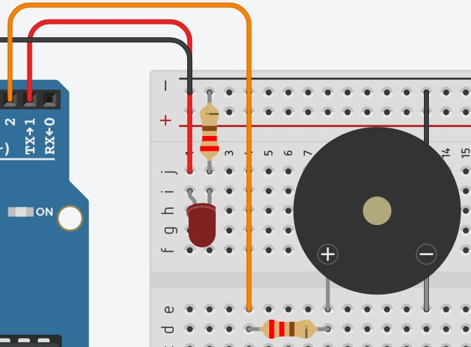

Figure 6: LED, buzzer and its resistors

4. LCD Integration:

The 16x2 LCD serves as the user interface, displaying critical information and alerts. We connected the LCD to the Arduino using the specified interface: GND – GND , VCC – 5V, RS - 6, RW – GND, E – 7, DB4 – 10, DB5 – 11, DB6 – 12, DB7 – 13, this will ensure proper data and control signal connections.

LCD Connection:

Figure 7: Blue wires connect to LCD

Figure 8: Light blue wires connect to VCC terminal on LCD

Figure 9: LCD

6. Pushbutton Integration:

To allow users to reset the system after a detection event, we integrated the Normally Open Pushbutton into the circuit. The pushbutton was connected to the 3RD pin on the Arduino, enabling its functionality.

Figure 10: Pushbutton connected to Arduino board

# Results:

During testing in simulated disaster circumstances, the human detecting probe system produced excellent results. The system successfully launched a quick reaction strategy after precisely identifying the presence of human heat signatures beneath debris in numerous tests. The main outcomes consist of:

Accuracy: The PIR motion sensor successfully and reliably detected human heat signatures, reducing false positives and false negatives.

Alert Mechanisms: Rescue teams were efficiently informed of the existence of life beneath the rubble thanks to the visible and audible alert mechanisms, including the flashing red LED, piezo buzzer, and LCD display.

Speed: The system's rapid reaction methodology drastically decreased the amount of time needed to find and free imprisoned people, possibly saving lives in dire circumstances.

# Conclusion

In summary, our team built a human detection probe system that successfully identified human heat signatures in disaster response scenarios using a PIR motion sensor. The incorporation of a piezo buzzer, an LCD display, and a flashing red LED as alarm mechanisms improves the effectiveness of rescue teams in finding and freeing trapped people. When tested in simulated disaster scenarios, the technology shown excellent accuracy, speed, and safety. The idea offers enormous promise in speeding up life-saving rescue efforts in the wake of earthquakes and other disasters, even though additional real-world testing and refinement may be required for full-scale deployment. In the end, it has the ability to greatly enhance disaster response efforts and help save lives in dire circumstances.

# References

Anon., 2023. *How Search And Rescue Teams Find Survivors After Earthquakes.* [Online]   
Available at: https://firebuyer.com/how-search-and-rescue-teams-find-survivors-after-earthquakes/#:~:text=Ultra%2Dsensitive%2C%20seismic%20sensors%20use,and%20help%20pinpoint%20their%20location.  
[Accessed 5 October 2023].

BYJU'S, no date. *Light Emitting Diode (LED).* [Online]   
Available at: https://byjus.com/physics/light-emitting-diode/#:~:text=LEDs%20work%20on%20the%20principle,in%20the%20form%20of%20photons.  
[Accessed 5 October 2023].

Dhanesha, N., 2023. *How rescuers find survivors after deadly earthquakes.* [Online]   
Available at: https://www.vox.com/science/2023/9/11/23868632/morocco-earthquake-marrakech-search-and-rescue-efforts  
[Accessed 5 October 2023].

Herga, no date. *What is a Normally Open Switch?.* [Online]   
Available at: https://www.herga.com/news-media/technical-blog-archive/what-is-a-normally-open-switch-#:~:text=In%20a%20normally%20open%20switch,they%20are%20switched%20%E2%80%9Con%E2%80%9D.  
[Accessed 5 October 2023].

Narayana, S. et al., 2015. *PIR Sensors,* Bengaluru: Dept. of Electronic Systems EngineeringIndian Institute of Science.

Pultarova, T., 2023. *NASA's heartbeat-detecting tech to help with Turkey earthquake relief effort.* [Online]   
Available at: https://www.space.com/nasa-tech-helps-turkey-earthquake-rescue-effort  
[Accessed 5 October 2023].

Quisure, 2020. *What is the working principle of the buzzer?.* [Online]   
Available at: https://www.quisure.com/blog/faq/what-is-the-working-principle-of-the-buzzer  
[Accessed 5 October 2023].

Soldered, no date. *HOW TO USE: LCD 16X2.* [Online]   
Available at: https://soldered.com/learn/how-to-use-lcd-16x2/#:~:text=MODULE%20WORKING%20PRINCIPLE,-Explaining%20how%20LCD&text=It%20is%20based%20on%20liquid,they%20are%20rotating%20the%20light.  
[Accessed 5 October 2023].

Statheropoulos, M. et al., 2015. *Factors that affect rescue time in urban search and rescue (USAR) operations,* Athens: Natural Hazards.

Wang, A., 2022. *What is PIR Motion Detector.* [Online]   
Available at: https://www.mokolora.com/what-is-pir-motion-detector/  
[Accessed 5 October 2023].

# Appendix

Arduino Board code:

#include <LiquidCrystal.h>

LiquidCrystal lcd(6, 7, 10, 11, 12, 13);

int led = 1;

int buzzer = 2;

int pushButton = 3;

int sensor = 5;

int btn;

int snr;

bool found;

void setup()

{

pinMode(led, OUTPUT);

digitalWrite(led, LOW);

pinMode(buzzer, OUTPUT);

noTone(buzzer);

pinMode(pushButton, INPUT);

pinMode(sensor, INPUT);

lcd.begin(16, 2);

lcd.setCursor(0, 1);

lcd.print("NO MOTION DETECTED!!");

}

void loop()

{

btn = digitalRead(pushButton);

snr = digitalRead(sensor);

if (snr == LOW)

{

found = false;

lcd.clear();

lcd.setCursor(0, 1);

lcd.print("NO MOTION DETECTED!!");

digitalWrite(led, LOW);

noTone(buzzer);

}

else

{

found = true;

if (found == true)

{

lcd.clear();

lcd.setCursor(0, 1);

lcd.print("MOTION DETECTED!!");

tone(buzzer, 1000);

for (int i = 0; i < 10; i++)

{

digitalWrite(led, HIGH);

delay(500);

digitalWrite(led, LOW);

delay(500);

}

}

}

if (btn == HIGH)

{

found = false;

lcd.clear();

lcd.setCursor(0, 0);

lcd.print("MOTION DETECTED!!");

digitalWrite(led, LOW);

noTone(buzzer);

}

}